Chroma Online Clothing Store

*Prepared by:*

Ghadi AbouKhzam-2030627

Riham Harb-20230088

CIS Department, Rafik Hariri University

Cosc:333 Web Programming

Dr. Roaa Soloh

Fall 2024

Table of Contents

**Introducton3**

**Design Process3**

Sketches4

UI Design6

Screenshots6

Responsiveness12

**Implementation** 1**4**

Tools Used14

Challenges14

JavaScript Features15

**Testing and debugging15**

**Conclusion4**

1. **Introduction:**

Our website, **Chroma**, is designed to help customers discover their unique style effortlessly. Our vibrant, high-quality collection offers something for everyone, celebrating fashion as an expression of individuality. By simplifying the shopping experience, we ensure that finding the perfect outfit is not just easy but enjoyable. Whether you're embracing bold trends or timeless classics, Chroma is here to inspire confidence and creativity in every choice you make.

1. **Design Process:**

The Design of a website is just as important as the functionalities, having an appealing design grabs the customers’ attention. Our original color scheme sets our website apart from other clothing stores, the synergy between dark blue and pink brings out the details of both colors and helps set apart each section of our pages.

1. **Sketches:**

Sketch 1:

Sketch 2:

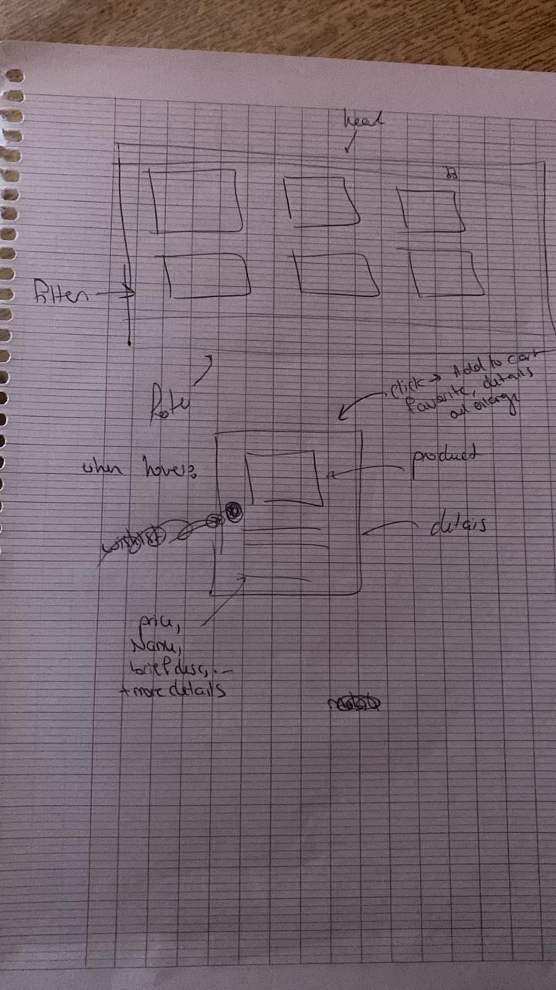

Sketches of the shop page which is the base of our website

1. **UI Design:**

When creating the UI our first consideration is making the website easily navigable while keeping our original palette of colors mixed throughout the pages in a unique way.

**Screenshots:**

* **Home page:**

When we first enter:

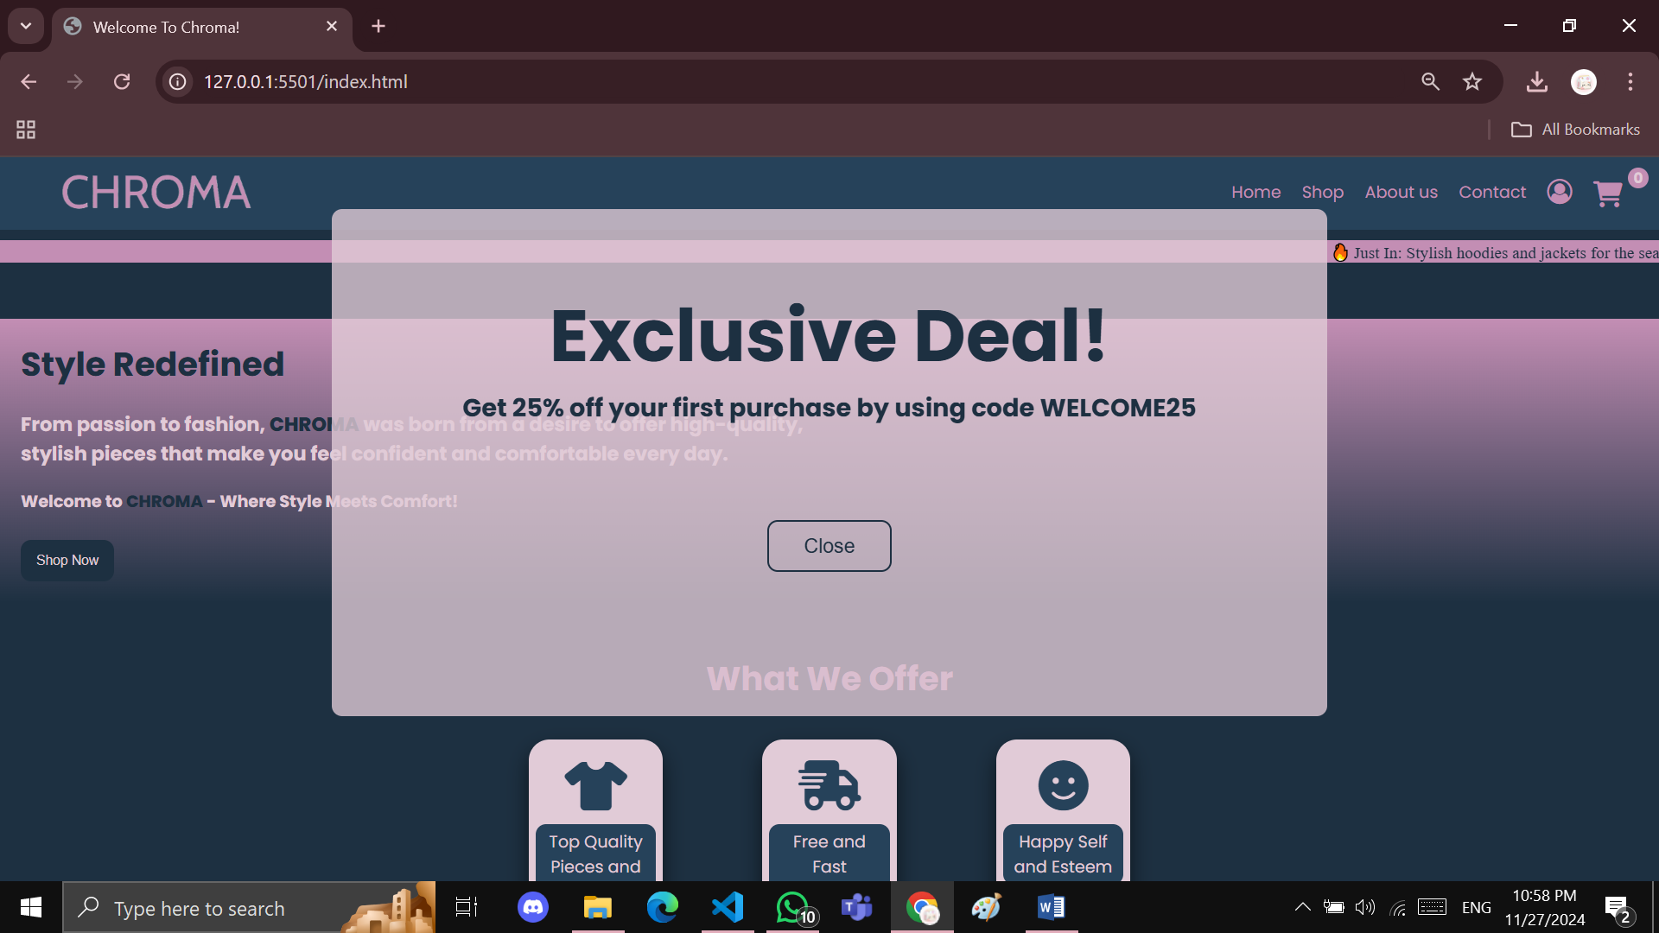

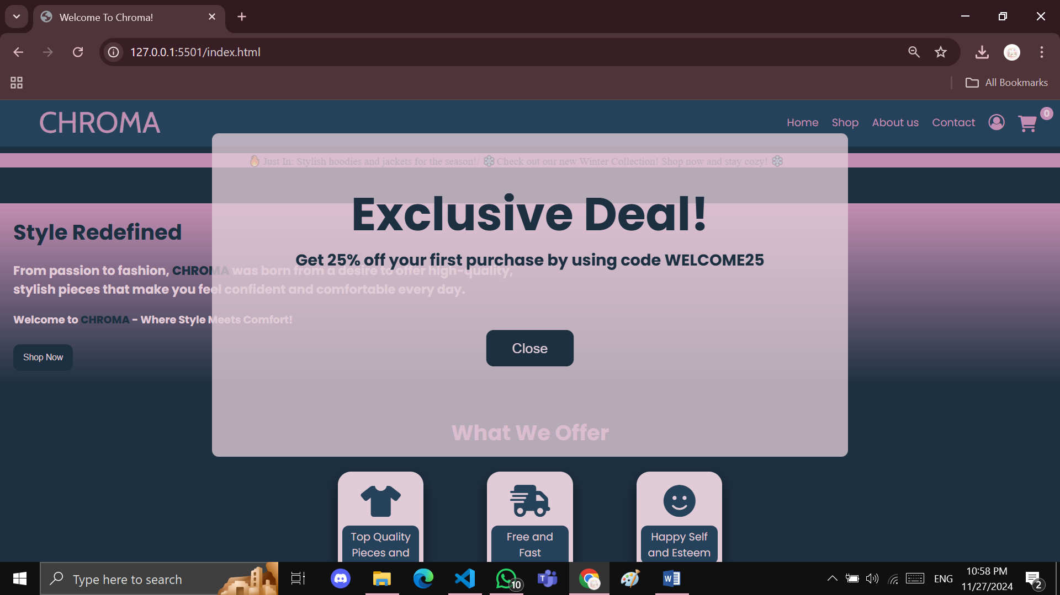

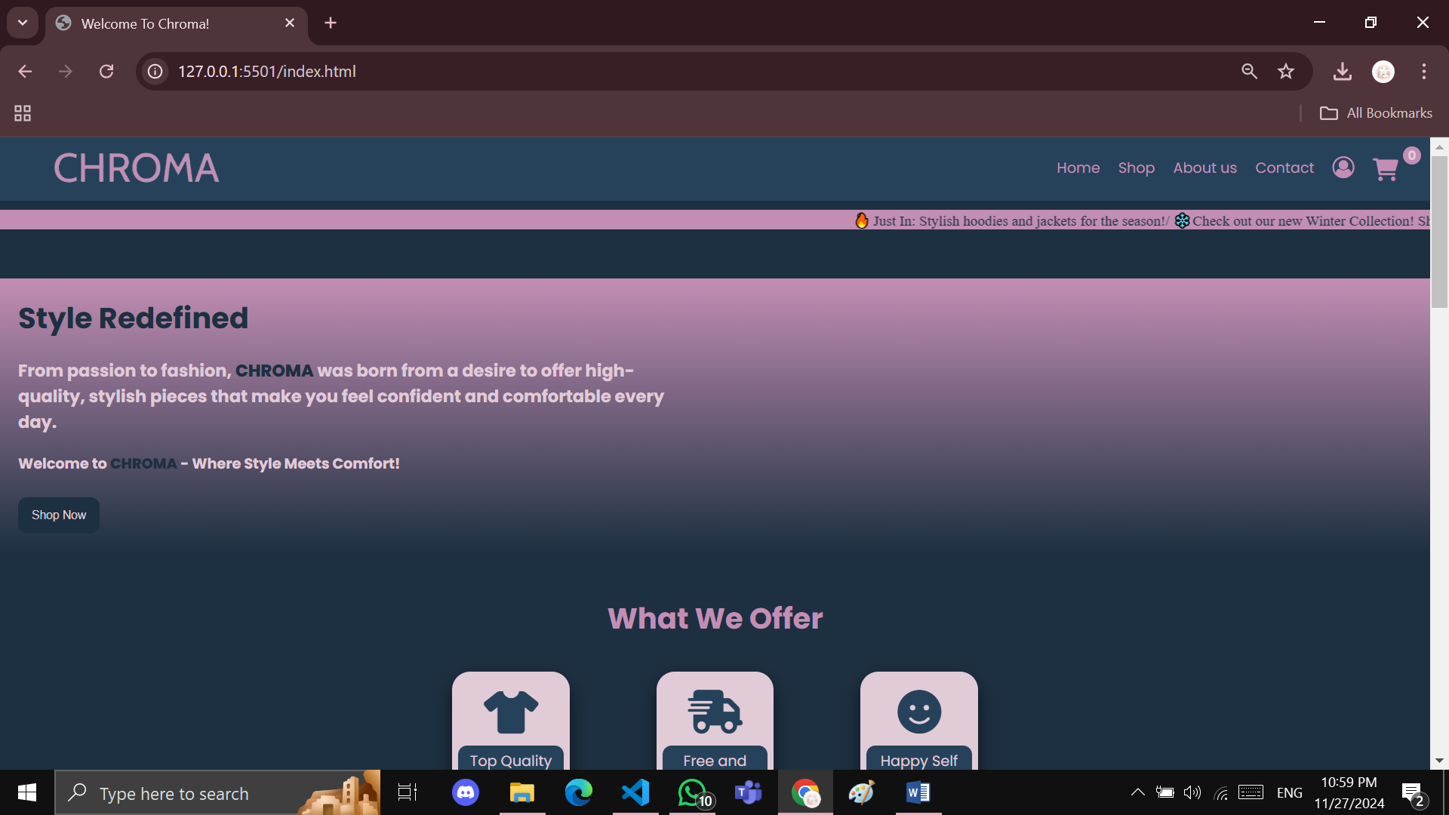

* **Hovering on cards(Animation):**

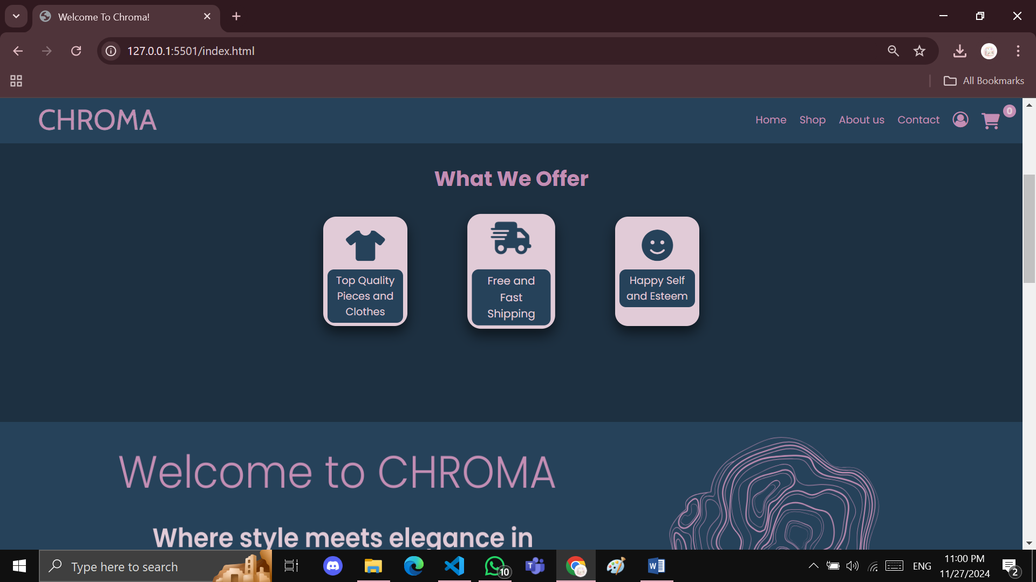

* **Carousel:**

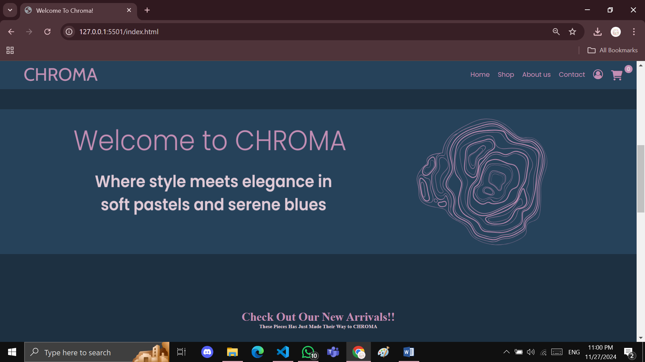

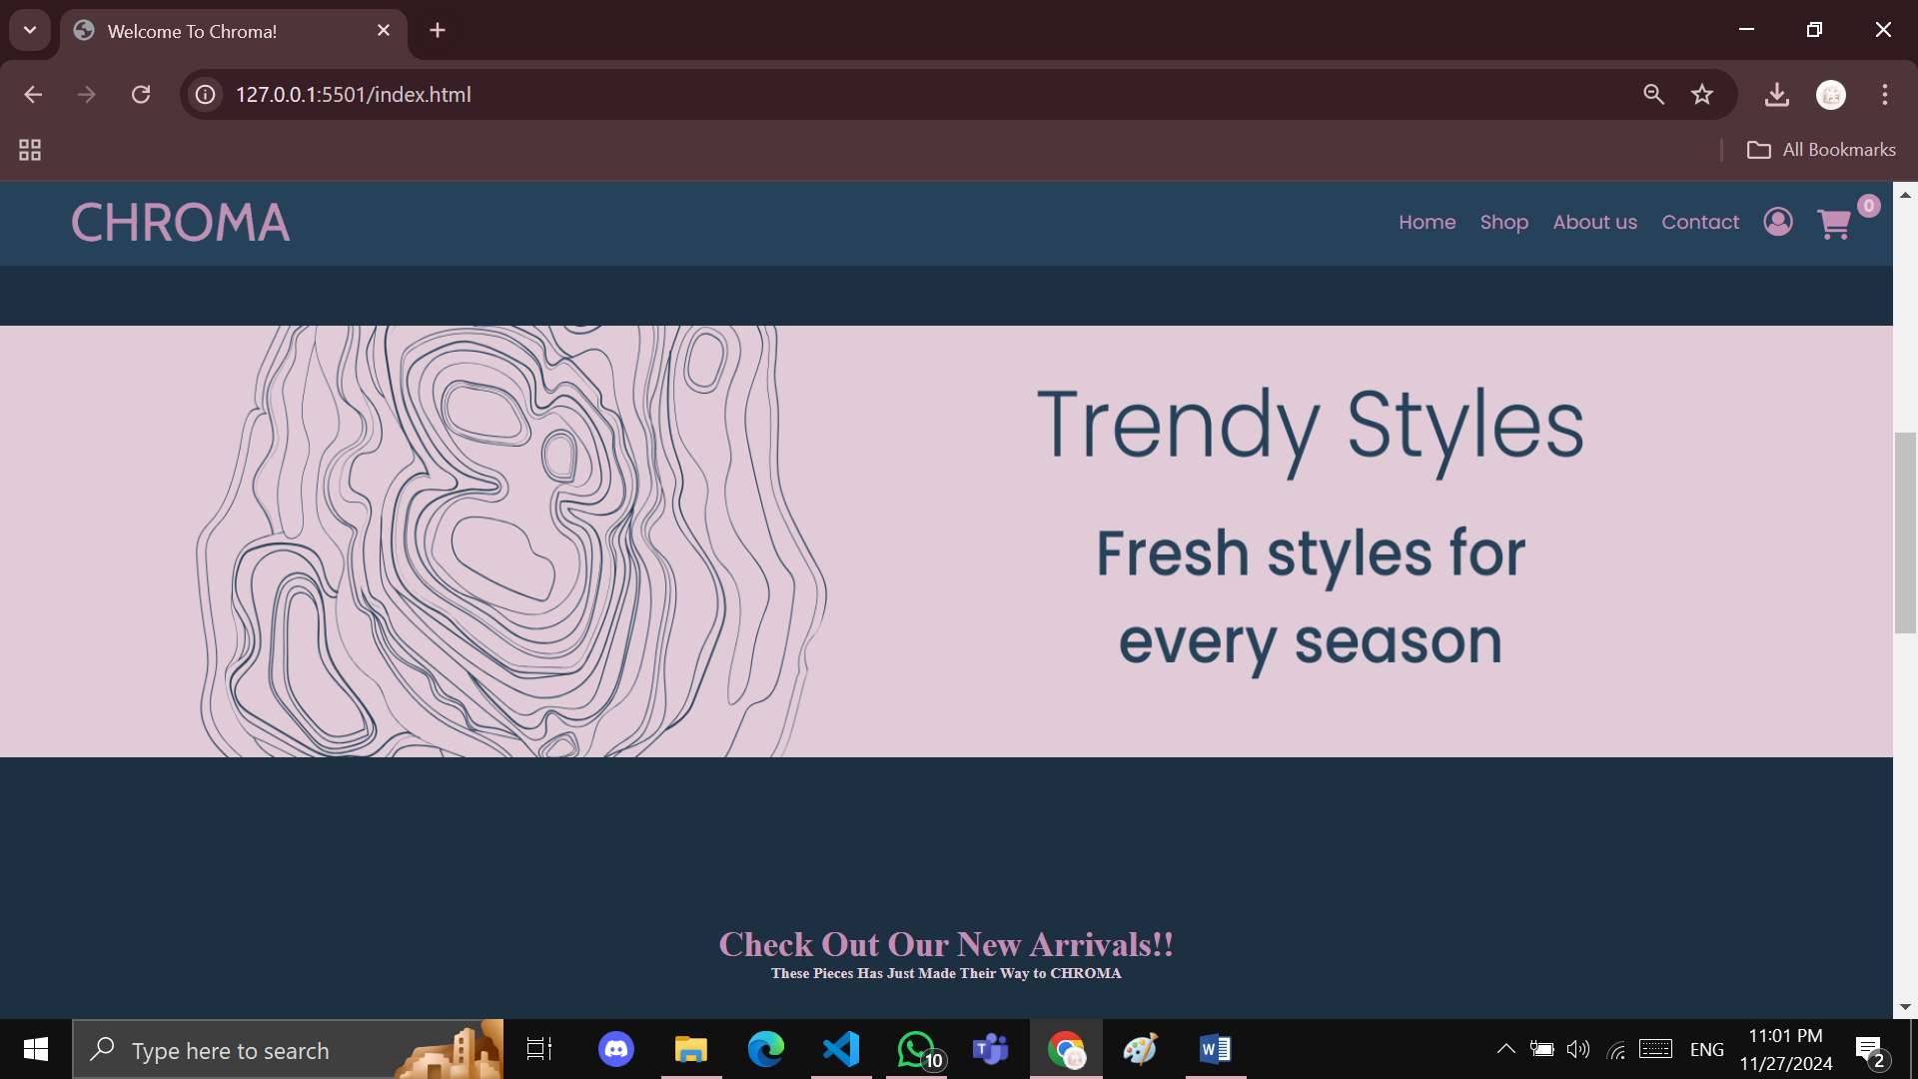

* **New Arrivals loaded by Json:**

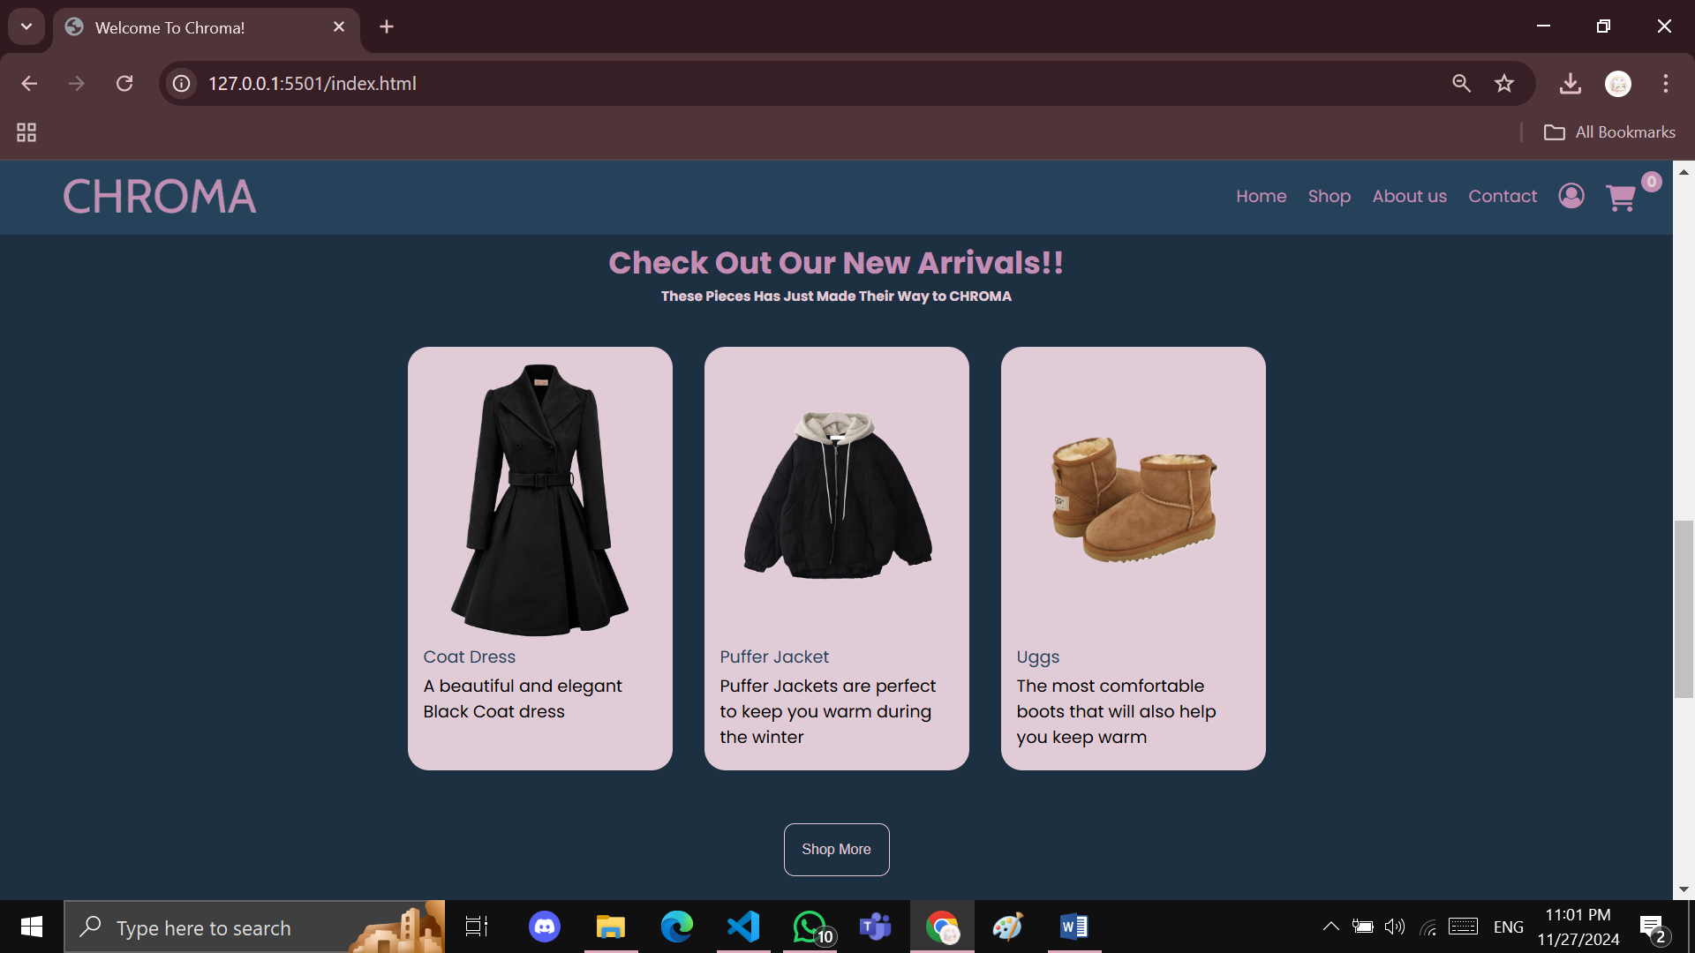

* **When hovered:**

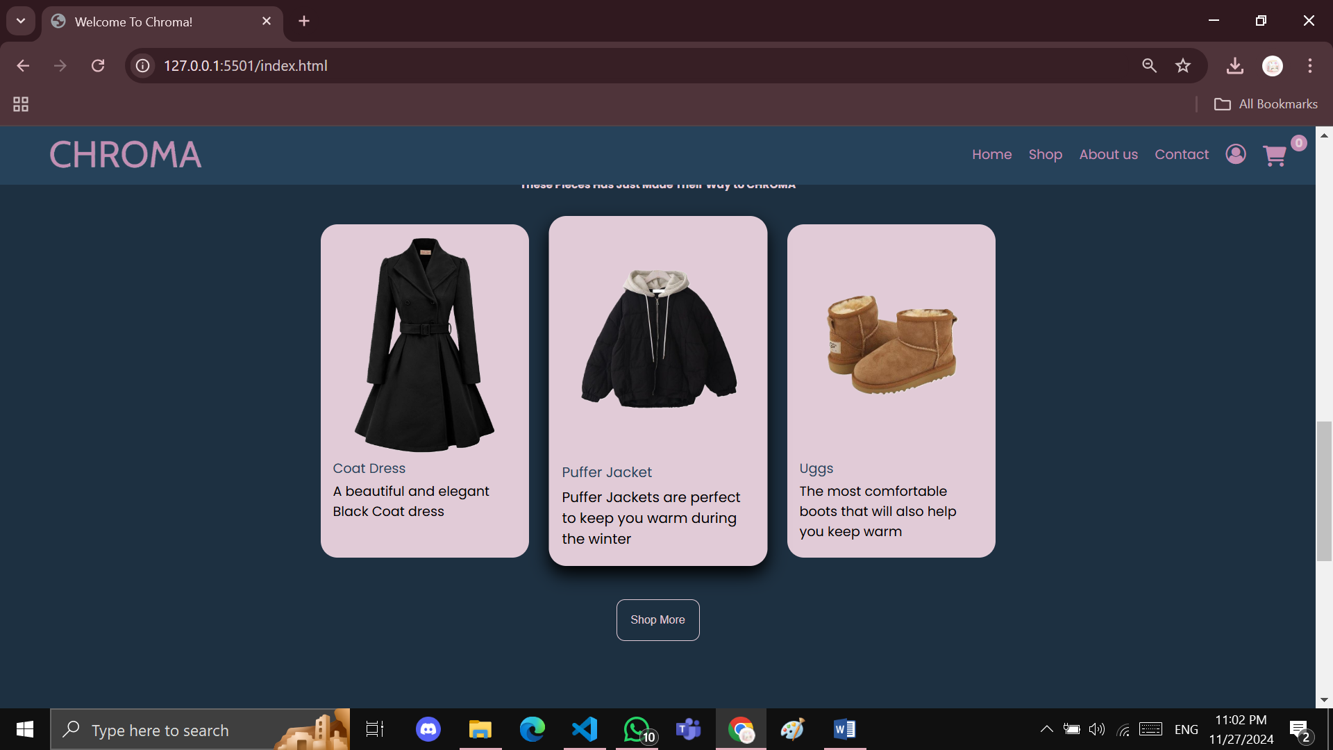

* **Product details slider:**

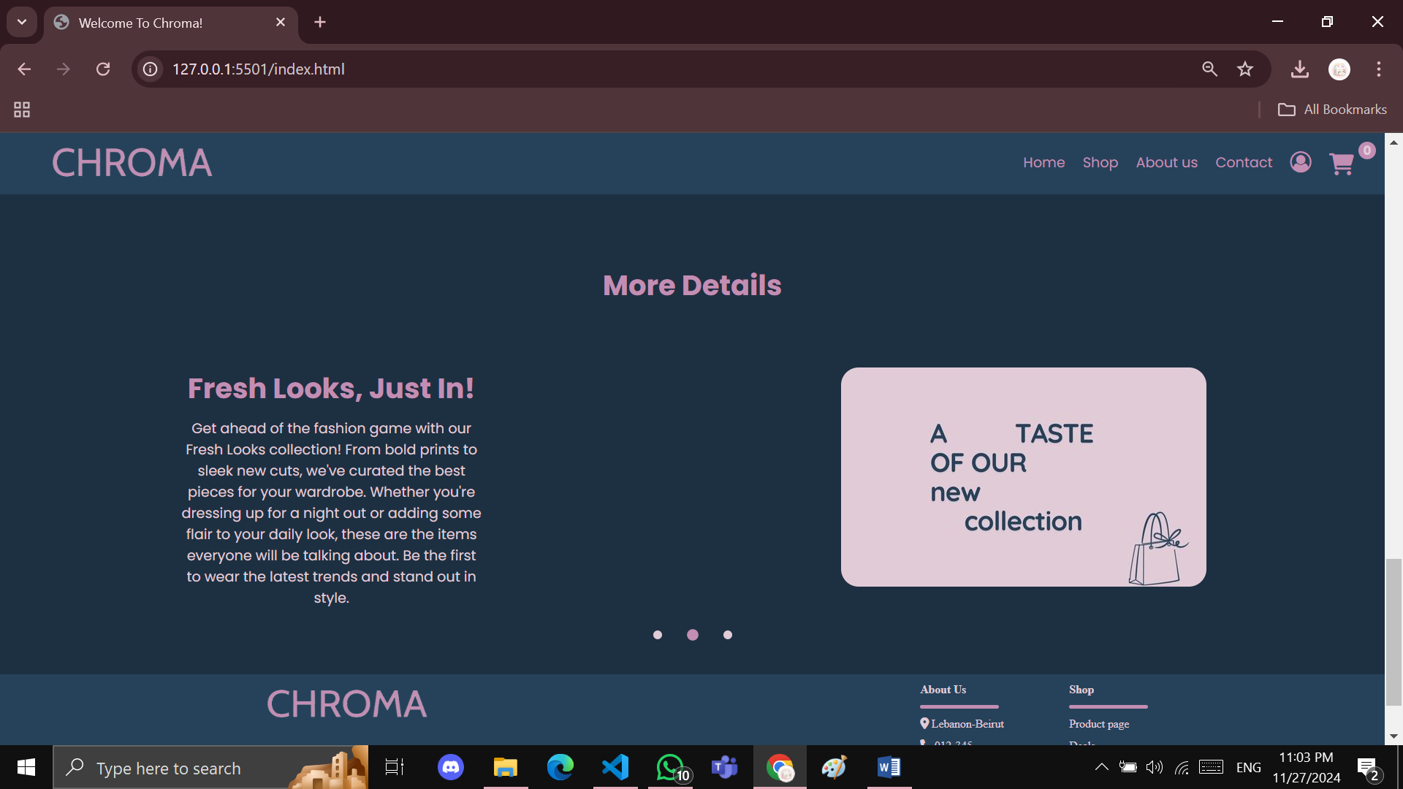

* **Shop page(Products are loaded dynamically by Json):**

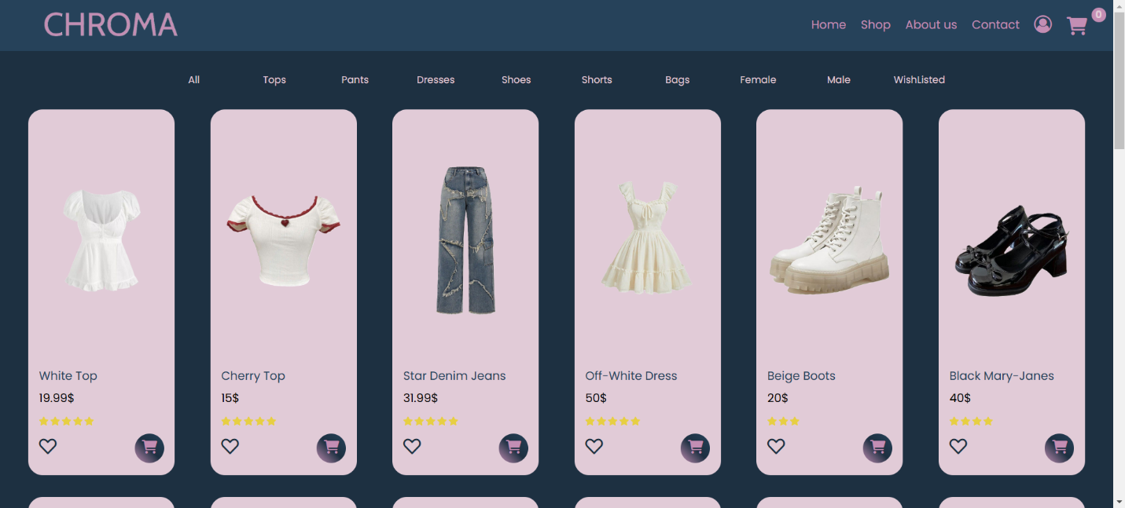

* **Filter in action:**

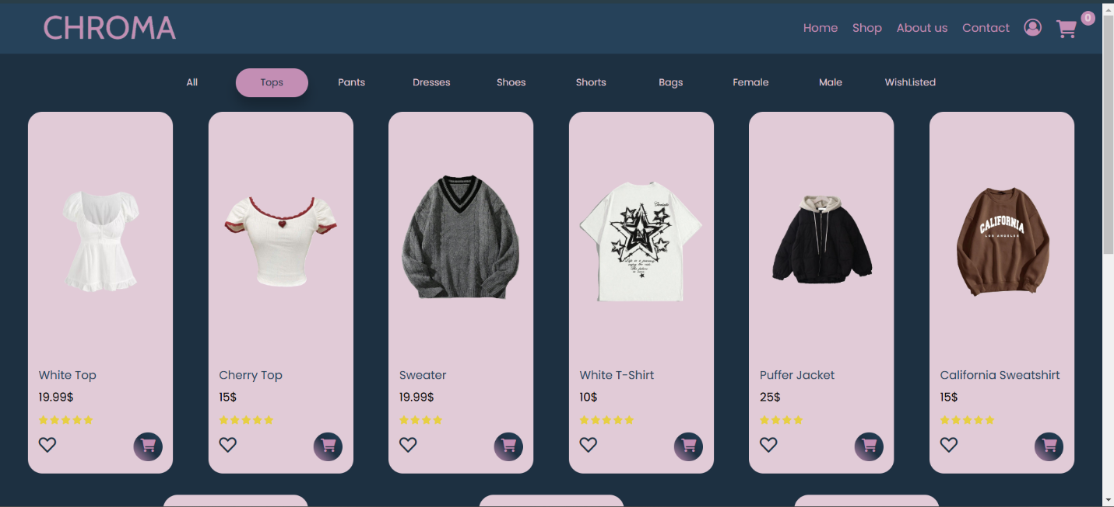

* **Wish list Filter:**

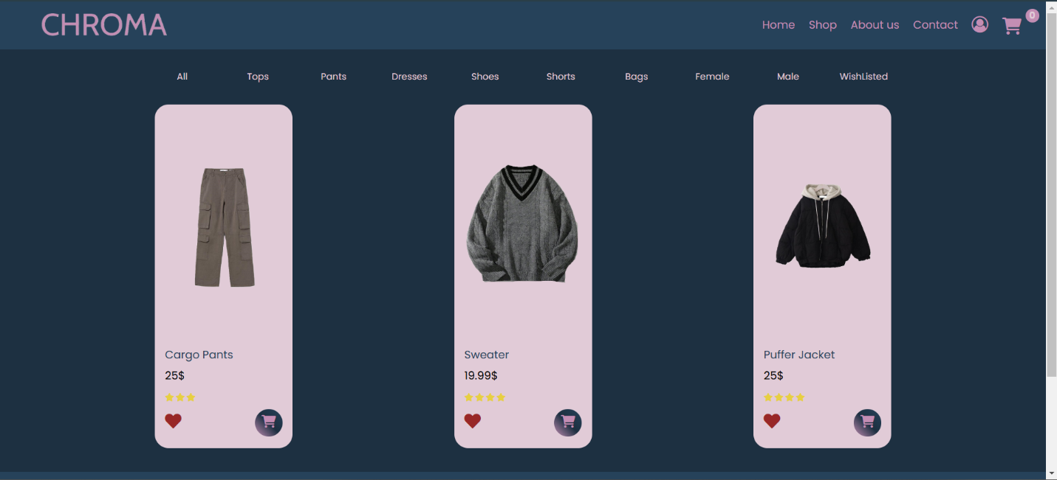

* **When adding an item to the cart the counter increases and the user receives a pop up message:**



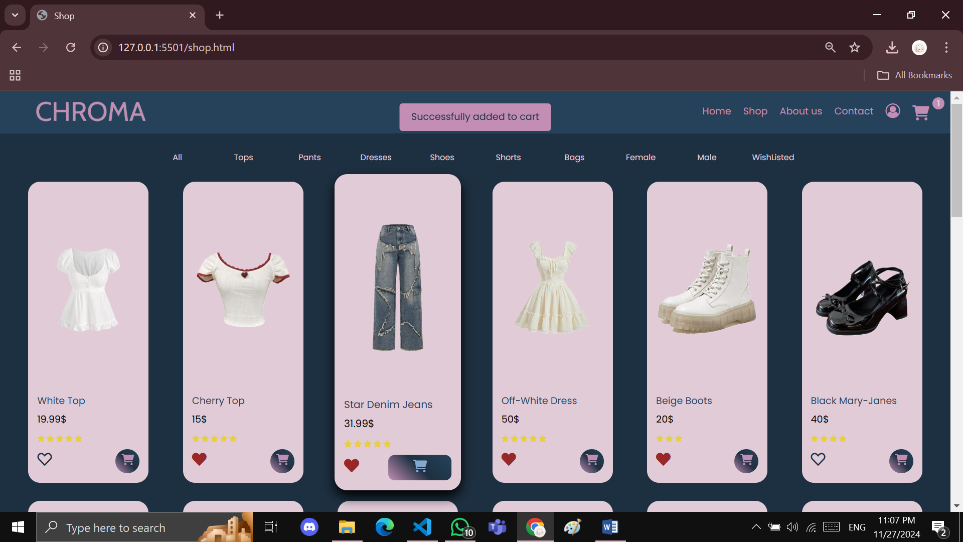

* **Cart page:**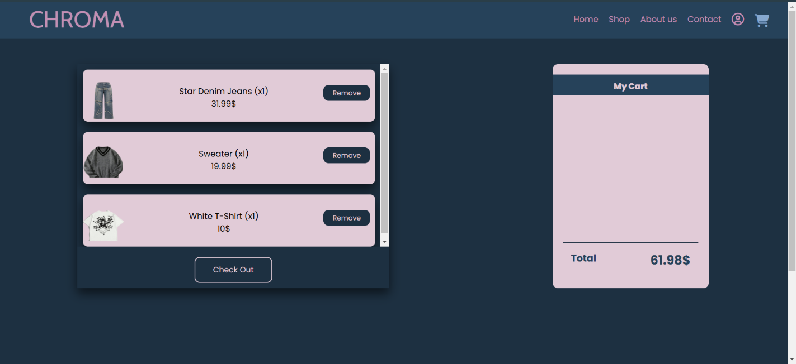
* **Empty Cart:**

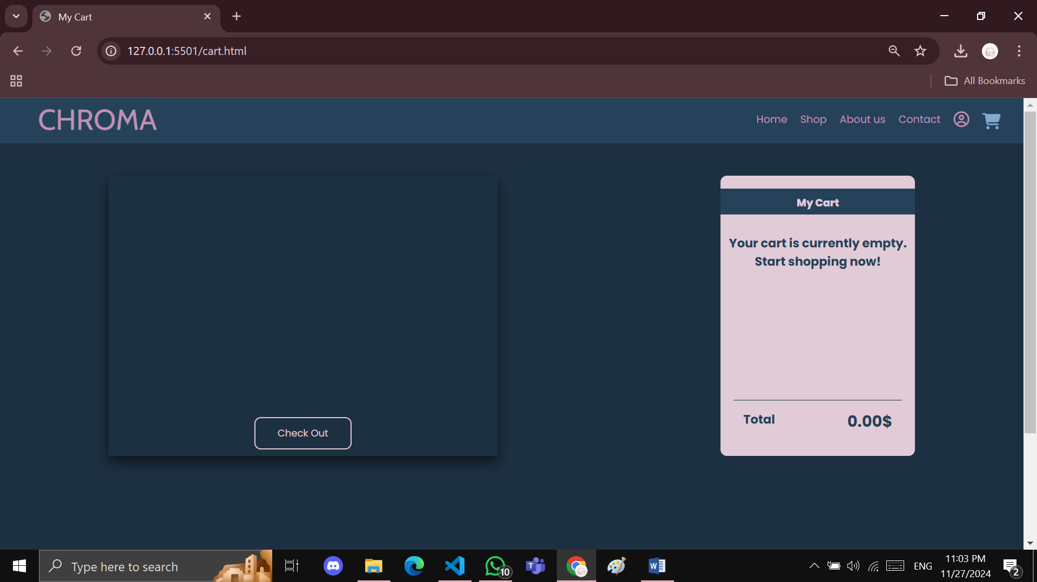

* **Adding duplicates in the cart:**

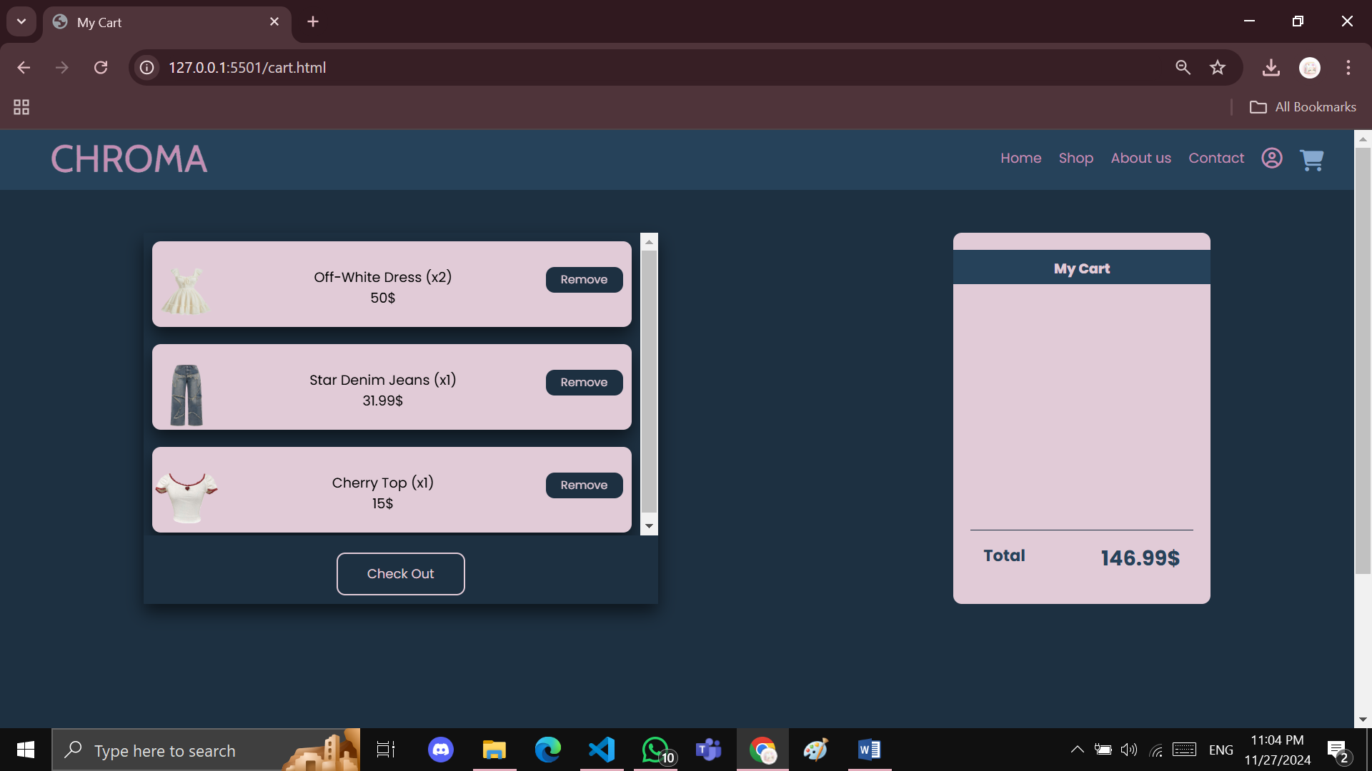

* **Removing an item from cart (Dress become x1 instead of x2):**

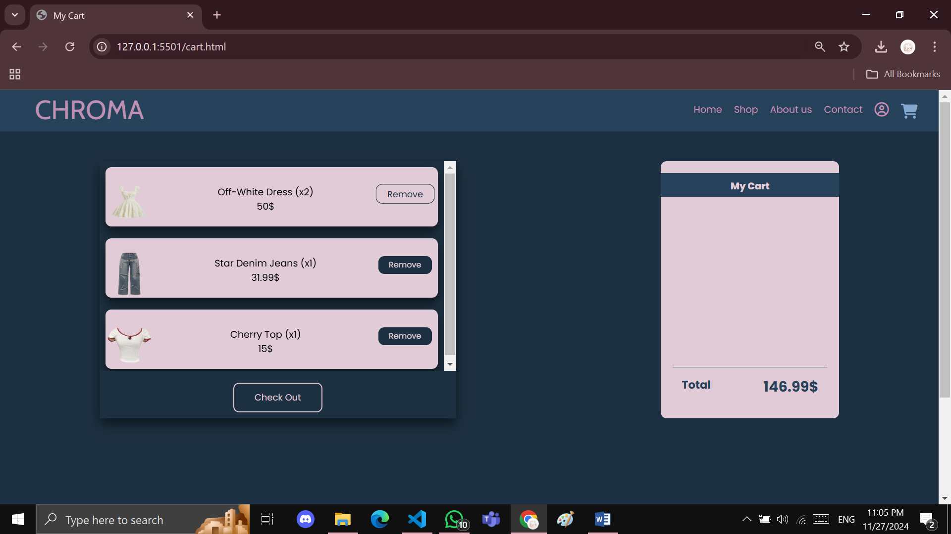

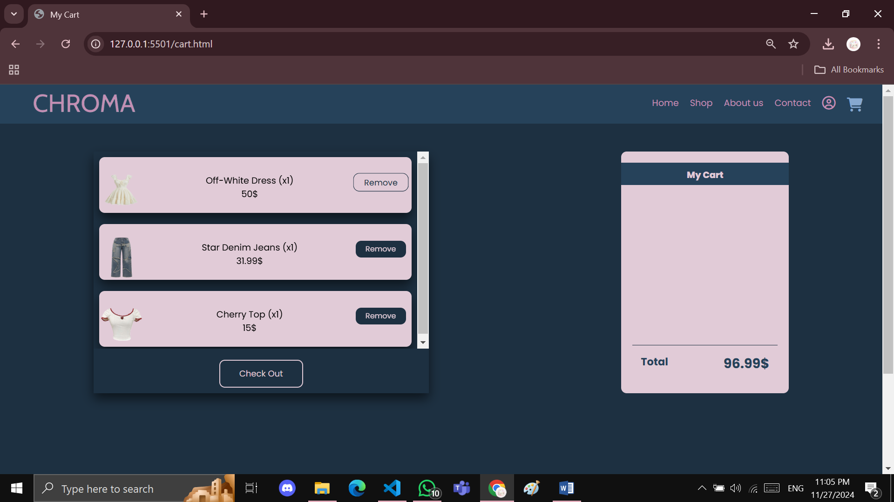

* **Trying to check out an empty cart:**

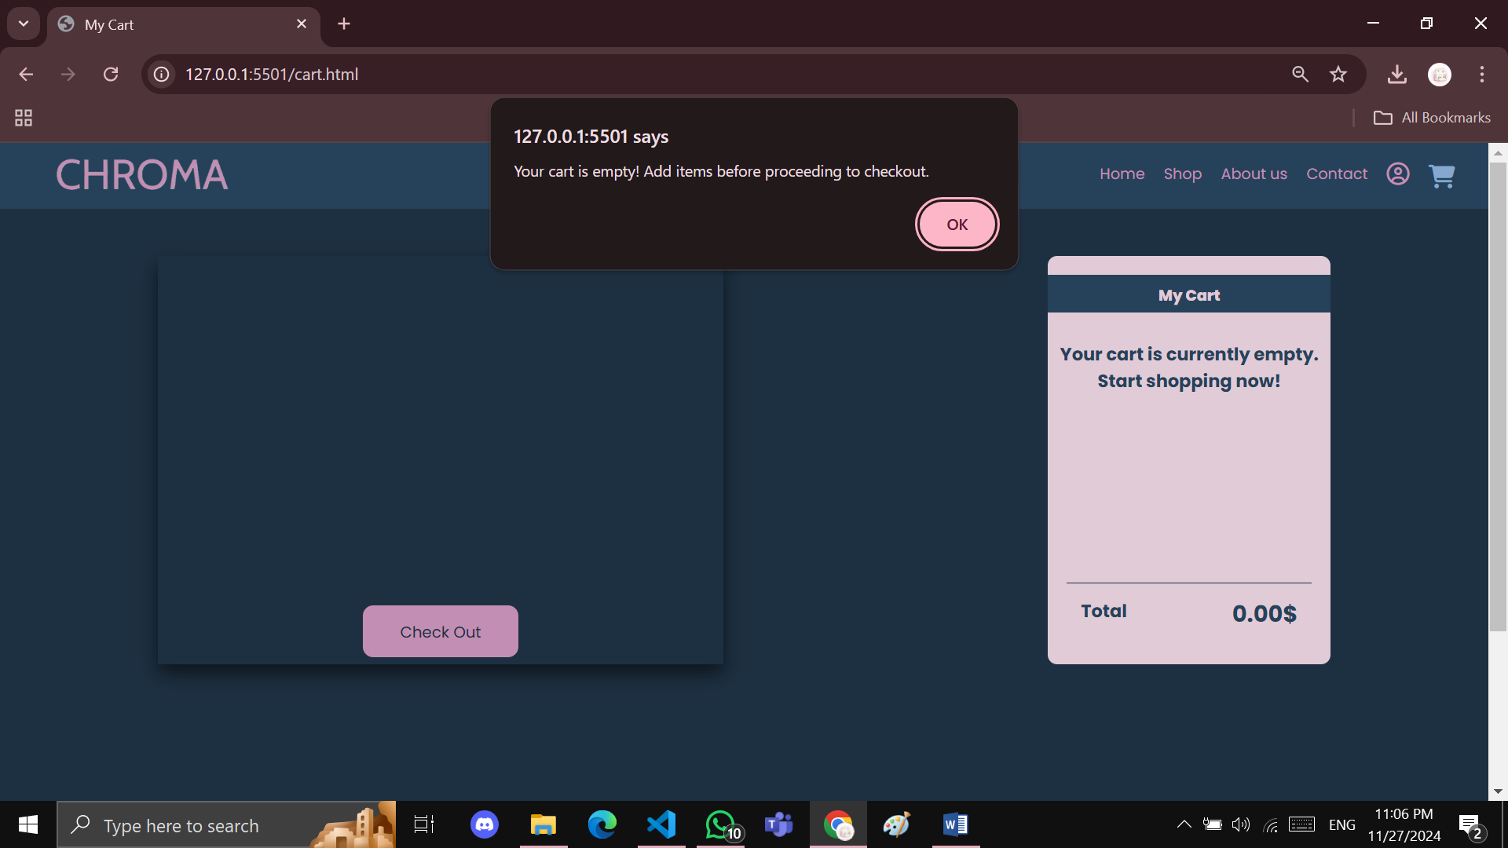

* **Footer, common across all pages**



* **Contact Us Popup window**

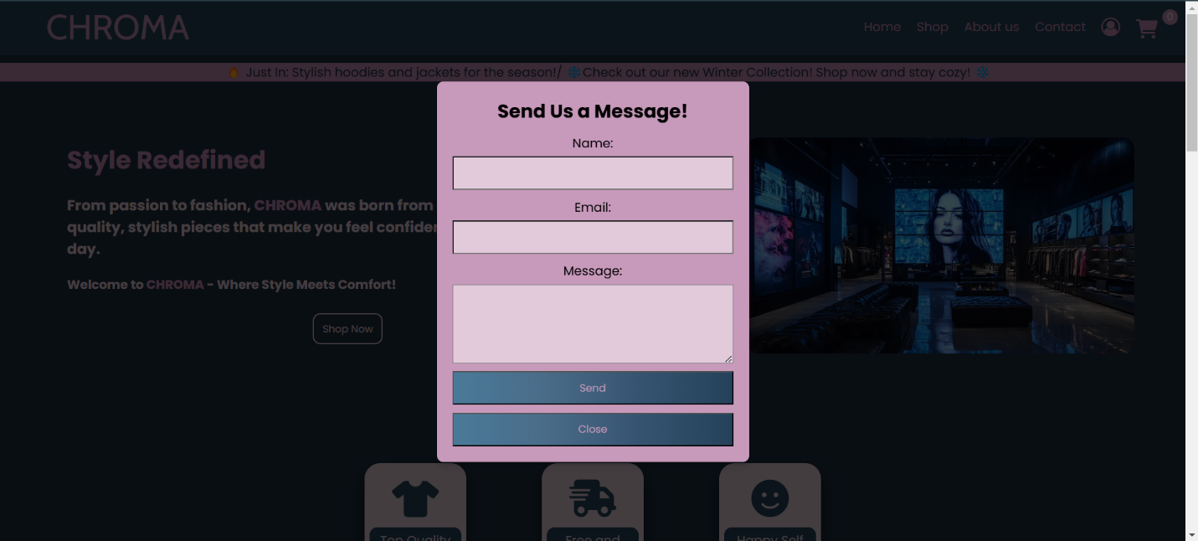

* **Login/Signup page**

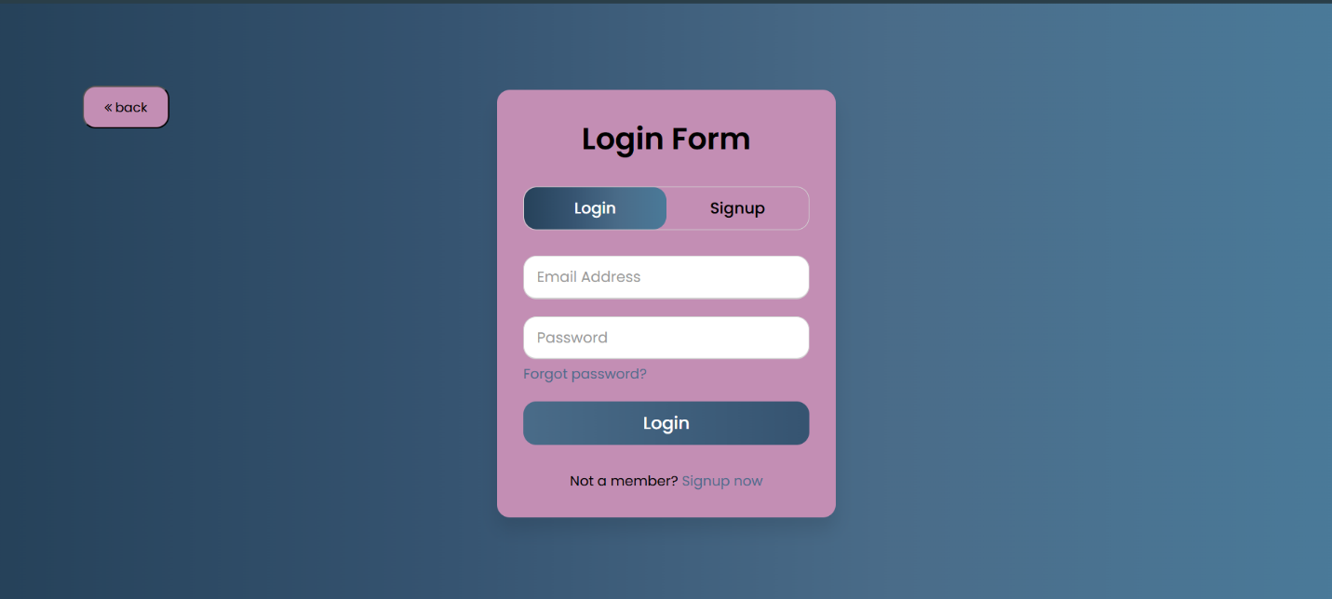

* **About Us page:**

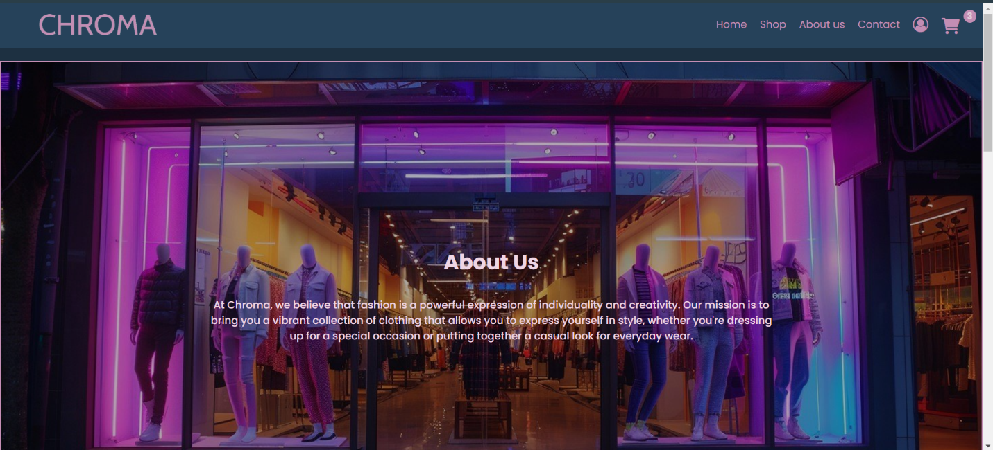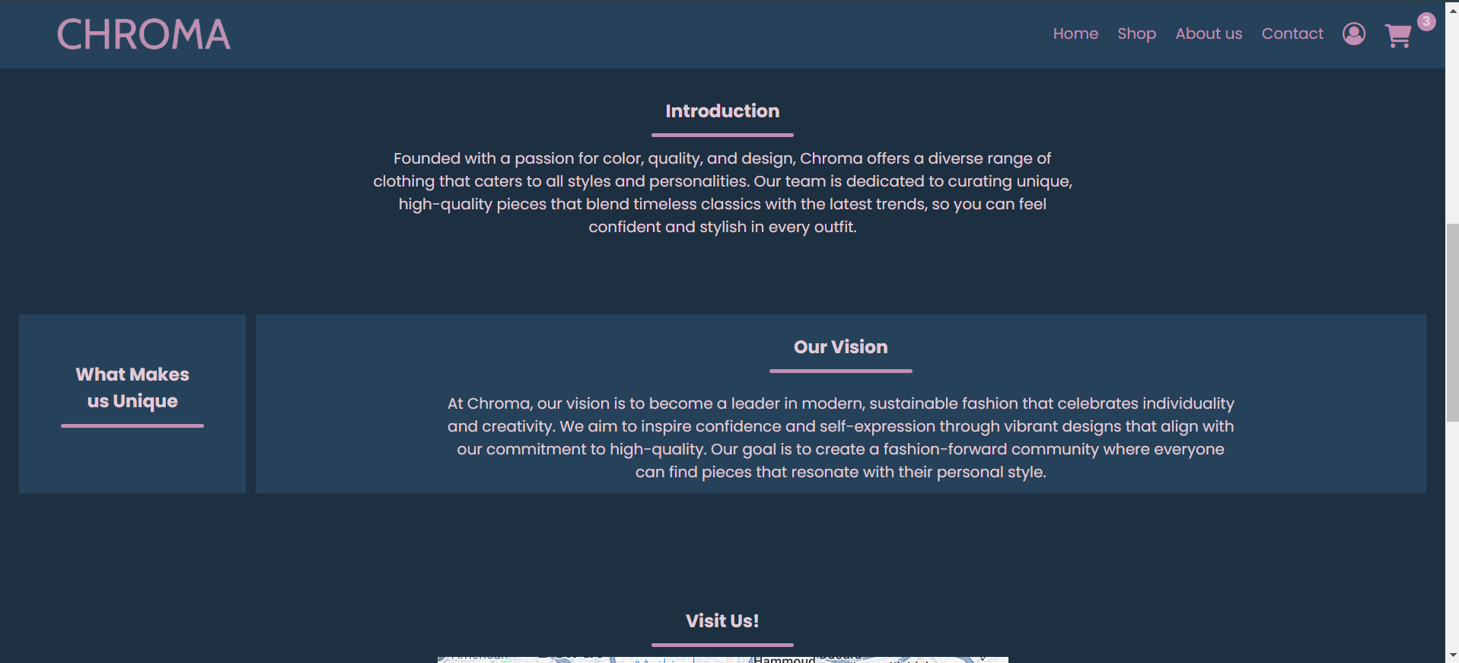

1. **Responsiveness:**

The website wraps nicely on a smaller screen

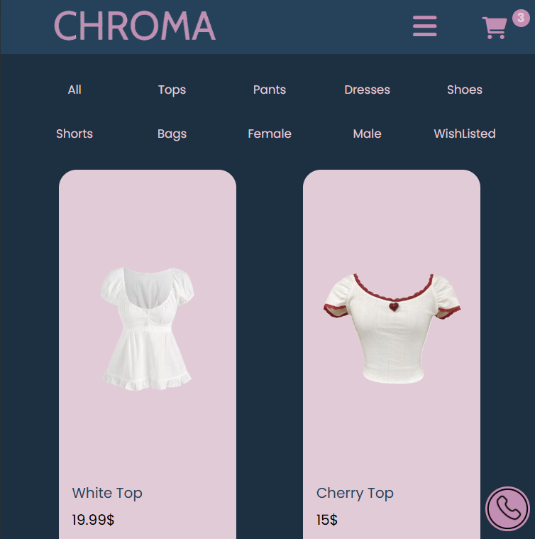

The menu is condensed into a hamburger menu that can be expanded to overlay on other pages

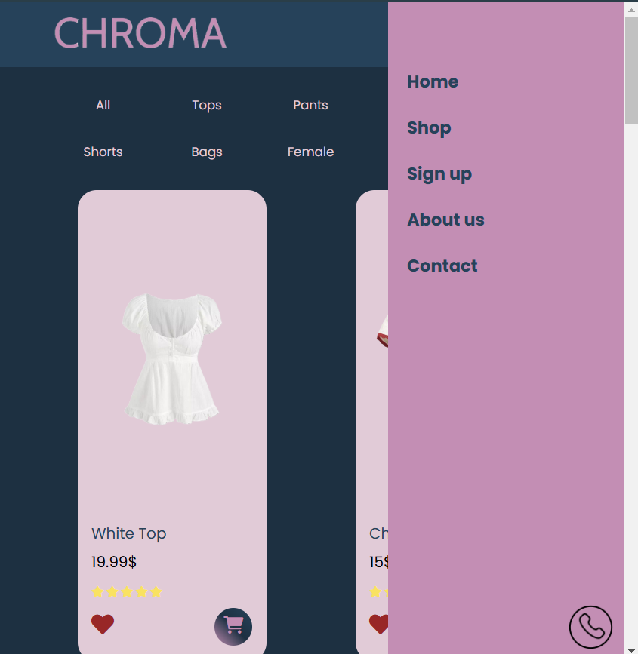

1. **Implementation:**

* Tools used:

1. Html: the base of every website used to add elements and content.
2. CSS: the tool used to adjust and style the elements added in the html.
3. JavaScript: used to customize content and add functionalities to dynamically interact with the webpage.
4. Json: helped with data used for the cart and login pages.
5. jQuery: simplified the use of JavaScript.

1. **Challenges:**

Responsiveness: faced challenges with making the website fit on smaller screen, solved using media queries and help from the web.

JavaScript Features:

JavaScript is used in most pages on our website:

* Firstly, for the hamburger menu display on smaller screens
* Used for adding items to cart with help from Json
* Some animations and transitions
* Filters in the shop page
* Changing pictures on the home page
* Popup windows

Testing and Debugging:

Testing was used to check functionalities and responsiveness as well as the use of console.log and browser developer tools to check for errors throughout the webpages like broken navigation links, slides not working as intended and sidebar being inconsistent. Testing and debugging led to improvements across all pages leading to a better more put-together project.

Conclusion: